OPI Guidance for Substandard Housing Determination (Unsheltered) for Students Identified as Homeless

*Homeless Liaisons should consider multiple factors when determining if a family’s or unaccompanied*

*youth’s situation meets the criteria of homelessness due to substandard housing.*

* Home must have a solid foundation and a roof that does not leak
* Security locks must be on all exterior entrance doors
* Home must be free from insect or rodent infestation
* Home should have no more than five unrelated persons living in a single-family dwelling, or no more than two family members for each bedroom in the home
* Each room must have a window or duct to provide ventilation, and interior air must be free of harmful pollutants such as mold
* Home must have electric service and at least one electric outlet in each room
* Home must have adequate heating facilities, and hot and cold running water
* Home must have a separate kitchen and bathroom, each with an operational sink
* Kitchen must have space for storage, preparation, and serving of food, including a refrigerator and stove or range with oven
* At least one bathroom must have a bathtub or shower, flush toilet, sink, and offer privacy
* Every sleeping room must have a window or door providing access to the outside

*Additional factors that should be considered:*

* *The family’s financial situation and ability to obtain suitable housing*
* 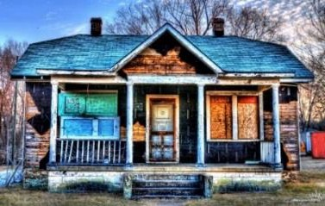*The overall care of the children, including personal hygiene, cleanliness of clothing, nutrition, and healthcare*

\*Adapted from guidelines from the United States Department of Housing and Urban Development (HUD)

January 2025